Actions for this week:
Continue to deepen my understanding of several important concepts in my research field, and maintain a macro-level grasp and conceptual overview of the area.

What did I do this week? Why did I do this?
1. Because time is limited, I decided to build on my previous work and extend it rather than starting completely from scratch. Previously, I trained and tested four models (kNN, Random Forest, TST – Time Series Transformer – on the PAMAP2 dataset), and reported each model’s accuracy, size and inference latency.
2. I thought about how to integrate the large amount of new knowledge I have recently learned.
3. I examined the gap between my past work and journal/conference papers.
4. I reflected on whether code redundancy affects experimental quality. I took “designing a new model” as a goal, and at the same time considered whether a failed model that still provides in-depth analysis could count as a contribution or originality.
5. I整理ed and reviewed the knowledge points I have studied so far.
6. I investigated whether training and testing different models across multiple Colab sessions would affect experimental quality.
7. I thought about the differences between a UK master’s dissertation and journal/conference papers, and began to try designing a new model/algorithm.
8. Because new coursework tasks were released, I adjusted my subsequent plans accordingly.
9. I studied new models/algorithms proposed in journal/conference papers, looked at how they differ from each other, and asked whether they were designed from scratch or through small modifications. I also reflected on what strategies and ideas I could borrow when designing a new model/algorithm.
10. I thought about how to verify the effectiveness of a new model.

Why?
1. My previous work was done reasonably well, which proves that this path is feasible. There are very few works that test multiple baseline models on a given dataset and report not only accuracy but also model size, inference latency and energy consumption. Even this alone can significantly fill a gap in current research. And if I later compare the latest models and my own proposed model against classical/baseline models, that is an even more advanced direction.
2. If I only learn new knowledge without integrating it, then I merely “know about it” in theory but cannot apply it flexibly. Understanding how my work differs from others’ is the only way to see how to improve it.
3. By understanding the direct gap between my work and existing papers, I can see how many possible paths there are to improve it, and how much time and effort each path would cost, so that I can make better trade-offs.
4. Redundant code consumes extra time and energy, and also makes it harder for my supervisor to see the main points. A successful model, or one that improves in some aspects, often takes a lot of time and effort to design, plus many experiments for validation and comparison. If a failed model cannot be counted as contribution or originality, then the time spent designing it is largely wasted.
5. Organising the knowledge points according to the experimental pipeline helps me see clearly what new content can be added at each step of the experiment.
6. If too many long experiments are run in a single Colab session, then a disconnect would force me to restart everything. A single very long notebook can also make the web page sluggish, and later, once uploaded to GitHub, it will load more slowly.
7. Drawing on new ideas and ways of thinking from journal/conference papers, while at the same time strictly following the structure of a UK master’s dissertation, and combining the two, can help me significantly improve the final dissertation.
8. Any large project usually goes through multiple rounds of adjustment, because we do not know what difficulties will appear later. Timely adjustment is essential to minimise risk.
9. Designing a completely new model/algorithm from scratch is almost as hard as “reaching the sky” – essentially impossible for a single MSc student. If I instead refine or modify the structure of an existing model, the workload becomes much more manageable.
10. Without rigorous experiments and enough baseline models for comparison, there is no way to tell how good a newly designed model really is, because there is no reference point.

Outcomes and findings:
1. Extending my work on top of previous results makes things much easier. Because I already have a foundation, I can better see the weaknesses in my earlier work and more easily find ways to improve it. The four models used previously are too weak as a baseline set, especially because they do not cover the most advanced models.
2. Using everyday analogies helps me understand new knowledge more effectively.
3. There is a noticeable gap between my previous work and journal/conference papers, especially in experimental rigour: statistics and uncertainty, multiple random seeds, more baseline models, cross-dataset evaluation, and so on. However, my earlier data preprocessing was done quite well, and under the same accuracy metrics, my results are similar to those reported in previous papers.
4. The most important thing is that the code runs successfully and produces trustworthy results. A failed model that nonetheless provides in-depth analysis can still count as a contribution and as originality, as long as I can explain the underlying principles clearly.
5. My understanding of the human activity recognition field has become significantly deeper.
6. Using multiple Colab sessions to train and test different models does not harm experimental quality, on the condition that all variables except the model itself are locked and kept identical.
7. The structure of a UK master’s dissertation differs quite a lot from that of journal/conference papers; they use different formats and structures.
8. Because this semester has three assignments rather than a single standalone dissertation, I need to start experiments as early as possible.
9. For new models/algorithms in journal/conference papers, very few are designed completely from scratch. Many papers simply modify a small module, and as long as there is improvement in some aspect, they can be published.
10. To verify the effectiveness of a new model, I should not only compare it to traditional models, but also against the strongest contemporary SOTA models.

Reflection:
1. Building on previous work still requires adding truly useful and necessary experiments, rather than casually adding a few baseline models and one or two datasets. I need to think carefully about why I need each chosen model as a baseline, and why I am adding particular elements. The purpose is to improve the quality of the experiments, not just to increase quantity. Ideally, the baseline models should cover the most representative models in the field and reflect the historical development of the area.
2. Although everyday analogies help me understand new concepts better (for example, comparing strict data splitting to cutting vegetables into evenly sized pieces, or comparing top conferences/journals to inventing a new dish/sauce/cooking method on top of strict cooking procedures), they are still two different domains. The best approach is to immerse myself more in my actual research area so that familiarity comes naturally.
3. I now have a clear and concrete picture of the weaknesses in my previous work, and I know how to improve it in order to reach the level of journal/conference papers.
4. If time allows, I should try to keep my code as concise and clean as possible. While this does not affect the results, it greatly improves readability for my supervisor.
5. There are many knowledge points in the human activity recognition field, but the key research directions and pain points are only a few. The “core directions/pain points” that determine research value and innovation are concentrated around a small number of big questions, rather than a hundred unrelated small ones.
6. Colab is very helpful for an MSc project like mine, and my later experiments should be able to proceed smoothly with it.
7. Each university and each programme has different requirements and formats for dissertations. To achieve a satisfying outcome, I will still need to communicate frequently with my supervisor.
8. The project process accounts for 40% of the mark, so I should take time to think carefully about how to do this part well.
9. If I want to design a new algorithm/model, I should set aside time to study the most advanced models in the field, with publication dates as recent as possible, just as I would carefully choose up-to-date references.
10. I need to think about how to design a more rigorous and comprehensive experimental pipeline.

Have I finished this week’s action? What percentage? If not, how to improve?
Completion rate: 90%.
To improve, I will use analogy-based learning and the “minimum necessary” principle, focusing only on the knowledge points that are most essential.

Actions for next week:
Prepare to start the ethics application, begin writing the proposal, and get ready for the first meeting with my supervisor.

09.22
I plan to use my previous work as a foundation and expand on top of it. This approach is relatively safe, the risks are controllable, and I am already somewhat familiar with this field. The first step is to identify all possible theoretical innovation points and then choose one or two of them. After searching, I found the following directions:
Lightweight Transformer architectures: borrow ideas from efficient Transformer designs and create small Transformer models tailored to wearable time-series data.
Cross-modal feature alignment mechanisms: PAMAP2 comes from multiple sensors (such as IMU and heart rate), so their features need to be fused effectively. I could introduce cross-modal alignment and attention mechanisms to let the model automatically focus on the importance of different sensors.
Data augmentation strategies: for time-series from wearable sensors, introduce diverse temporal data augmentation techniques, such as noise perturbation, time warping, and sensor rotation.
In addition, there are directions such as improving domain generalisation and optimising time-aware modelling, and so on.

I realised there are far too many potential innovation points, and I do not know where to start. I would really like to do several at once, but then I remembered Einstein’s quote: “Even a small subfield of research can consume a person’s entire life.”

I also learned about uncertainty estimation: introducing measures of predictive uncertainty into the model outputs to increase the credibility of the results. Possible implementations include adding Monte Carlo Dropout during training (performing multiple random dropout samples at inference time and computing the standard deviation), or training a Bayesian neural network with a small number of additional output parameters to directly estimate confidence intervals. In addition, the entropy of the prediction score distribution within a window can be computed as an uncertainty measure.

I came across the DANN algorithm, a domain adaptation method.

I found DAGHAR, which is a benchmark dataset collection. It unifies multiple common smartphone-IMU datasets (accelerometer + gyroscope) into a single format, making it easier to perform cross-dataset training/testing and comparative evaluations.

Because I have now encountered many new concepts and terms, I need to integrate and absorb what I have learned so far. I created a document to record almost all of the new knowledge and terminology I have come across. After some investigation, I found that the knowledge I have covered so far accounts for roughly 75–85 percent of the mainstream and cutting-edge topics in the IMU-HAR (Inertial Measurement Unit – Human Activity Recognition) field. This is an encouraging step forward. Once I fill in a few remaining pieces of the puzzle, I should have a sufficiently broad grasp of the whole field, which will help me steer my later experiments, understand what I need to do, and be clear about what I am currently doing.

I then checked what mainstream and frontier techniques I was still missing, and looked into how much coverage of mainstream and frontier methods is expected at different tiers of journals and conferences.

From this, I roughly concluded that my previous work covered about 50 percent of the mainstream techniques and about 25 percent of the frontier ones. Knowing the gap between my work and others’ helps me plan my future research.

One thing I need to pay attention to is that, if I want to experiment with 3 datasets and 7 models, I would need to run 3 × 7 = 21 model experiments. I realised this is unrealistic. Then I found a possible compromise: run 7 models on two datasets, then select 1 to 3 “champion” models and test only those on the final dataset. This greatly reduces the workload without harming experimental quality.

Another point is that when we say a top-tier conference/journal paper has “≥ 90% mainstream coverage,” this refers to covering the main steps and major method families, not every tiny sub-method. For example, for distillation, it might only use offline teacher–student plus response/logit distillation, rather than trying every single distillation variant. So, when choosing experimental methods, I should aim for those that are both recent and authoritative, just like selecting references.

I suddenly wondered: given how many new techniques and methods exist in the field, does achieving high coverage of mainstream and frontier techniques require a huge amount of code, like tens of thousands of lines? After checking, I found that sometimes a few hundred or a few thousand lines of code are completely sufficient; it is not as exaggerated as I imagined.
That said, environment and hardware checks/version handling, plotting figures, diagnostics/printing/saving, and similar tasks can significantly increase the total code size.

I also thought about whether having relatively redundant source code, as long as all the required functionality is correctly implemented, would affect the experiments and their quality. The result of my investigation is that as long as the code runs, can reproduce the experiments, and has a clear structure, it is acceptable. However, redundant code does affect how the work looks, the cost of reproduction, and the reviewer’s experience. In my later experiments, I should try to keep the code as concise as possible. As it turns out, I have indeed done this (note added on Tuesday, 11 November 2025).

Another question came to mind: because project time is limited—only three months, or possibly even less—I may not be able to design a breakthrough new model/algorithm. As a fallback, if I do propose a new model/algorithm but the improvements are quite modest (for example, in accuracy, energy, or model size), can such a model still be written up in the final project/dissertation? I need to ask my supervisor about this later, so I am noting it down for now.

I learned that journal and conference reviewers care more about “new knowledge and verifiable evidence” than about simply achieving the highest scores. The official ICLR reviewing guidelines explicitly state: “Failing to achieve SOTA is not, on its own, a reason for rejection; as long as the paper convincingly brings new, relevant and impactful knowledge, it can be accepted.” I therefore infer that if such work is acceptable for journals and conferences, then it should also be acceptable for a master’s dissertation.

https://iclr.cc/Conferences/2025/ReviewerGuide

To better organise the concepts and terminology I have learned so far, I divided them according to the experimental workflow, which is also what I mentioned in my proposal. However, it is important to note that there is no need to rigidly follow Steps 0–15 as a fixed chronological order when writing the code; the actual sequence of experiments should be arranged according to the specific situation.

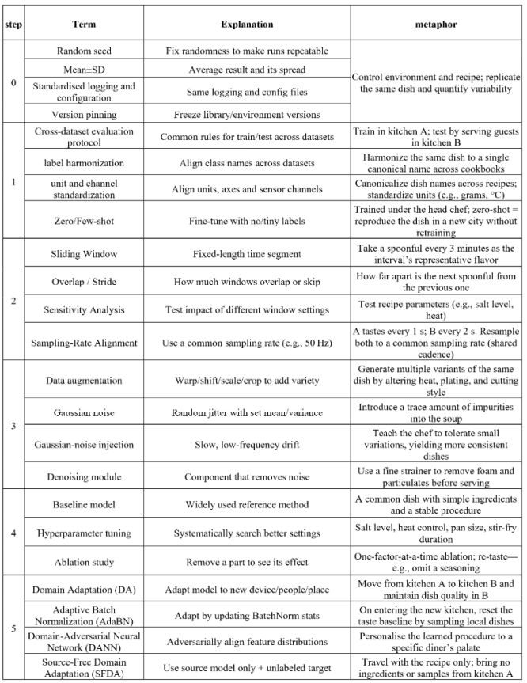
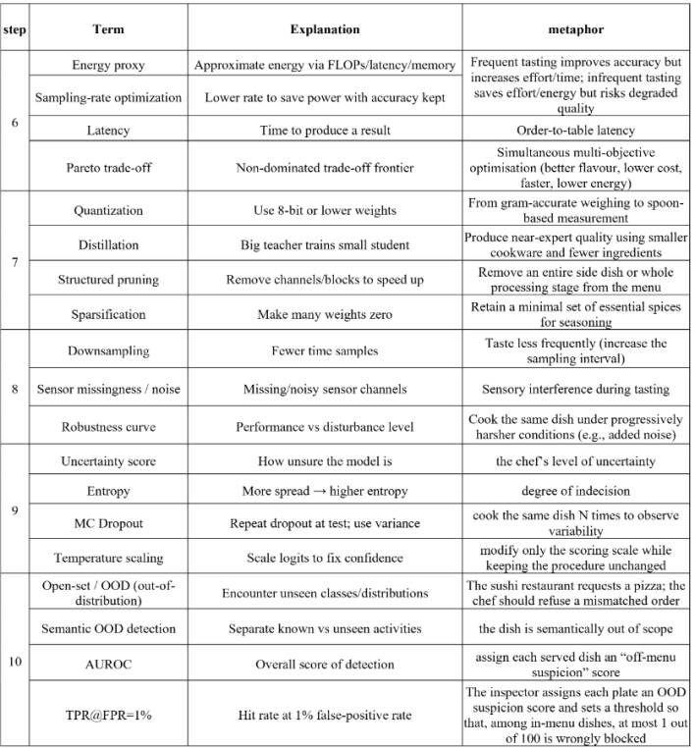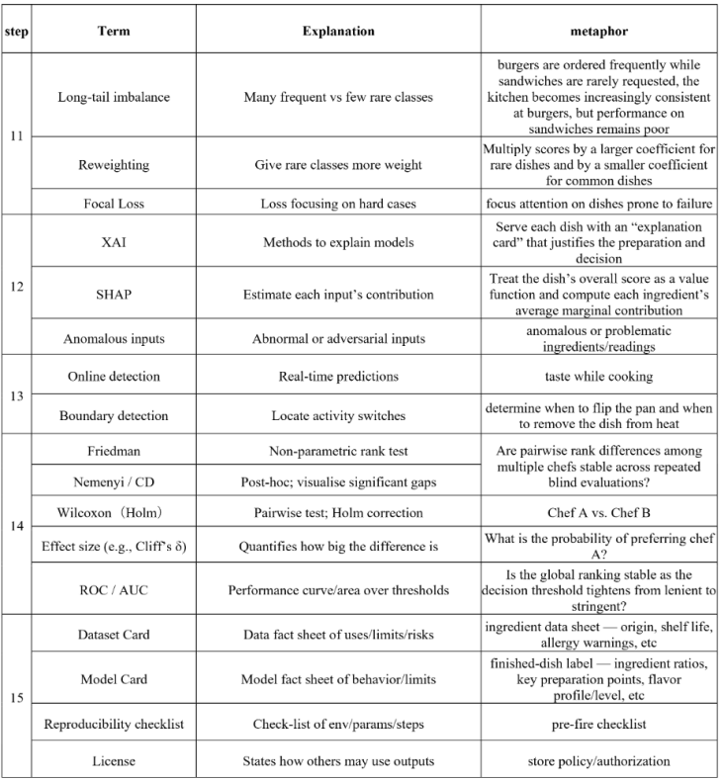

I suddenly realised that if I manage to cover mainstream techniques and evaluation paradigms with, for example, ≥85–90% coverage (complete baselines, standardised evaluation, statistically rigorous, high engineering reproducibility), and for the latest/frontier (2024–2025) directions achieve about ≥40–60% “representativeness,” but introduce almost no genuinely new methods or contributions, then the project/dissertation will look more like a complete and rigorous engineering reproduction.

09.23
I thought of a question. If, in a single Google Colab session (one .ipynb file), I both perform dataset preprocessing and also train and test multiple models (for example, six models), and then additionally run statistics and comparisons across models, and perhaps also add experiments such as measuring inference latency and energy consumption, would this make the code in one Colab notebook too long and too large? Moreover, Colab has a non-trivial risk of disconnection; if the session is interrupted during the experiments, I would have to rerun everything from scratch.

I can split the work into multiple Colab sessions. For example, I can create two separate .ipynb files, each running KNN and RF, and this is academically acceptable, provided that I truly lock all variables other than “model type” so as to ensure reproducibility and comparability. This situation is very common in journal/conference papers.

09.24
I learned that journal/conference papers and an MSc project/dissertation differ significantly in goals, evaluation criteria, workload and the level of “independence” expected. For example, journal/conference papers are very concise, whereas a UK master’s dissertation requires a much more substantial literature review, more detailed methodological derivations and engineering implementation, project management content (requirements analysis, milestones, risks/ethics/data governance), and detailed replication procedures plus reflection. In the dissertation, the supervisor will look at why I chose to do things in a certain way, how I validated them, failed attempts and limitations, and the trade-offs I made under resource constraints as evidence of “learning outcomes.” Therefore, when I read journal/conference papers, I need to keep this in mind: I can use them as references, but the final format and content of my dissertation still need to be planned and revised under my supervisor’s guidance.

At the same time, I briefly tested some new algorithms by implementing them in Python on Google Colab. Initially, the success rate was low and the code frequently crashed, mostly because the input data shapes and processing pipelines did not match. In this process, I was essentially just stitching together modules from different models/algorithms.

I then thought of another question: when a researcher designs a new algorithm/model, how do programmers translate it into code? Perhaps the design needs to be turned into a one-page specification, including task and objectives, input definitions, data protocols, model structure, loss/optimisation/training, and so on. By analogy, if I design a new model/algorithm, I will also need to write this kind of specification so that my supervisor can understand it.

I learned that even in top conferences/journals, most new algorithms/models are not invented completely from scratch. Many accepted works are new model variants, new training paradigms, new modules, or new problem settings. As long as the contribution is clear and the impact is substantial enough, the work can be accepted.

This semester’s coursework brief has been released: there are three assignments, which is different from what I initially imagined (a single 12,000–15,000-word dissertation). It seems I will need to make major adjustments to my future plans and schedule. My earlier planning was not thorough enough and needs correction.

After carefully checking, I found the following requirement in the dissertation brief:
“For this project you are not permitted to use datasets from Kaggle or the UCI Machine Learning Repository. These datasets are widely available, often pre-processed, and do not allow you to demonstrate the originality and independence expected at MSc level.”
This means I can no longer use the PAMAP2 dataset and will need to change datasets.

I learned that knowledge distillation is the process of transferring the decision distribution and intermediate representations from a large, strong “teacher model” to a smaller, faster “student model.” I saw this mentioned in one of the sample MSc dissertations I read earlier. Knowledge distillation is currently one of the mainstream methods, with offline teacher–student distillation being the main baseline. From my investigation, I found that TST, MiniRocket and MultiRocket can also be used with offline teacher–student plus response/logit distillation. Perhaps I can apply distillation to these models in later experiments, but I need to be very clear why I am distilling them and what my goal is.

In addition, because there are many kinds of distillation techniques, if I decide to use distillation in my experiments, I should choose the most mainstream and effective distillation methods currently used in the field, rather than trying every possible variant.

At the same time, I organized, structured and integrated all the terminology and knowledge I had learned so far, and grouped them into major categories, for example:

Under data and evaluation protocols: cross-dataset/cross-subject protocols, cross-validation strategies (LOSO, k-fold, different grouping combinations), multiple random-seed repetitions.
Under signal acquisition and preprocessing: sampling-rate optimisation, sliding-window segmentation, training-time data augmentation.
Under models and training: baseline models, new/modified models and hyperparameter tuning, self-supervised pretraining.

Other major categories include robustness and extreme conditions, system-level optimisation and deployment, and so on. I have almost reorganised and categorised all the current knowledge points in this field. This has laid a solid foundation for selecting which techniques to include in my later experiments.

After this week, I now have a rough overall understanding of the field.
At the same time, I realised that I have learned too many concepts and techniques, and in practice I may only be able to use a small subset of them in my experiments, because time is limited. Furthermore, the success of the project is not determined by how many techniques I use, but by having one clear core claim, a small number of mutually reinforcing technical components, and rigorous, comprehensive evaluation.

09.25
From my investigation, I found that in journal and conference papers many “new” algorithms/models are actually very similar to existing ones: quite a few get accepted by changing only a single sub-module, loss function, training strategy, or by introducing a lightweight variant. Most papers do not create an entirely new paradigm from scratch. More often, they make non-trivial extensions, reorganisations or unifications within an existing family, or they propose harder/more realistic problem settings and evaluation protocols together with effective solutions.

At the same time, I started to wonder: if I take very recent top-conference/top-journal algorithms/models and improve on them, would the results be strong? However, this may raise the bar for incremental contribution, strengthen the comparison targets, and make reproduction harder. It might actually be a good choice to take a mainstream model instead of the latest one, apply one main modification plus one lightweight variant, and then make the methodology and evaluation as rigorous as possible.

Simply proposing a “new algorithm/model” without any verifiable improvement or insight (in at least one dimension such as accuracy, robustness, resource usage, theory, or evaluation paradigm) is not automatically a plus for a paper.

I have summarised three feasible routes for the dissertation project:
Route A (safest): problem-driven improvements to training, inference, data, and evaluation;
Route B (middle ground): small but solid module-level innovations on top of recent SOTA;
Route C (high risk, high reward): early-stage prototypes of entirely new architectures/paradigms.

I checked the new algorithms/models from the last two years in my research area, prioritising those with public source code because they are easier to reproduce. Each of these new methods is designed to address a different pain point in the field.
In addition, the update frequency of new models/algorithms/hybrid variants in IMU-HAR has been very high in recent years: around 240 papers in 2023 (about 20 per month), and around 360 in 2024 (about 30 per month).
My next step is to decide which specific problem in this field I want to solve, and then dive into the papers on methods targeting that problem. Otherwise, there are simply too many papers to read.

In academic contexts, “new model / new algorithm / hybrid approach” is often a composite concept: architecture × objective and training procedure × data and augmentation × inference mechanism (including TTA), all packaged together as “our method.” So many “new methods” do not just swap out the backbone network; the main innovation may lie in the training or inference side.

I now have some new ideas about how to design a new model/algorithm.
Path A: focus on a single pain point and make a strong improvement to existing SOTA.
Path B: change the problem definition or evaluation framework so that old methods fail while my method excels.
Path C: cross-domain transfer, bringing mature ideas from domain A into domain B.

If I design a new algorithm/model, it may perform well in some aspects (for example, recognising walking) and poorly in others (for example, recognising running). This would require in-depth analysis, for example using visualisation and explainability tools to identify the model’s weaknesses and then improve it in a targeted way.

I also need to show that, under real-world constraints (mobile/edge devices, low bandwidth, low energy, real-time), my method yields reusable design principles or general recipes and systematically pushes the Pareto frontier. Moreover, experiments must explain why the new model works and why it improves over previous methods. For example, ablation studies can reveal which specific parts of the model are actually responsible for the gains.

I learned that MiniRocket and MultiRocket are two very similar models. MultiRocket is an extension of MiniRocket that adds more feature transforms (such as first-order differences). Including MultiRocket in my experiments, rather than only MiniRocket, may make the results more convincing.

09.28
If I need to do cross-dataset evaluation, that means training on dataset A and testing on dataset B. Because different datasets can differ in sensor types, sampling rates, wearing locations and activity label taxonomies, leaving everything unconstrained will amplify or dampen model performance and lead to unfair comparisons. So it is necessary to standardise the input modalities and signal processing, for example: sampling rate, window length/stride, and gravity removal.

After sorting through a lot of the knowledge I have learned so far, I now basically know what experiments I want to run for the dissertation project. Being able to fix the rough experimental plan at this point in time means my current progress is acceptable.

In my previous work, I used LOSO as an evaluation protocol. By chance I saw a very similar term, LODO. After some research, I found that LODO means taking one entire dataset as the test domain, while the remaining datasets are combined for training/validation. In summary, LODO is very similar to LOSO, but the goals are slightly different: LOSO aims at “deploying to unseen users in the wild,” whereas LODO aims at “remaining stable under entirely new data sources.”

I learned that MiniRocket and MultiRocket can also be distilled and extended into variants. The Rocket family is currently a light, fast and accurate strong baseline, so it might be possible to create an even stronger model via distillation and variants. If that works, it would be a genuine contribution. But if I decide to go in this direction, I first need to check carefully whether there is already similar work.

I also need to use new evaluation schemes, or at least not blindly follow fixed schemes used in past work. For example, I should move from only looking at accuracy to also paying attention to cost.
Old scheme: only report accuracy or F1 score.
New scheme: I must also evaluate resource usage, such as
• latency: how long does one inference take? (affects real-time performance)
• FLOPs: how computationally heavy is it? (affects energy consumption and battery life)
• memory (peak memory): can the model fit on the target chip?

I have started working on the ethics application. I remembered that last semester our lecturer Peter demonstrated the entire ethics application process. I had saved those videos, and now I am going back to them to review.

